Our Club House
The Smith House
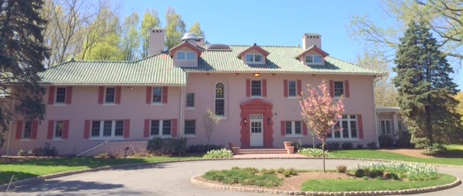
Smith House, Our Club House. The Smith House at 400 Sayre Drive is a Georgian style mansion constructed in the early 1900s for the Director of the Rockefeller Institute for Research. It serves as our club house for both meetings and social events. With its courtyard, the Smith House is a genteel setting for private parties available for rental by residents (max. occupancy 120).
The Management Office is located on the second floor of the Smith House. The office hours are 10 a.m. – 1 p.m. and 3 p.m. – 5 p.m. (M-F). Also open every weekday from 10 a.m.-5 p.m. and 6-9 p.m., and on Sat./Sun. from 10 a.m.-6 p.m. for our residents (unless there is a private party rental), so check the PL website calendar before coming over or call 609-243-9292 during the day to confirm access. Otherwise there is no need to pre-plan, just walk in and have fun with some friends. Visitors must sign in at the monitor’s office on the first floor.
The Smith House is closed on all major holidays.
The Smith House facilities include several meeting rooms, a piano, three TVs, a computer station, a children's room, an exercise area, pool and ping pong tables. The kitchen is available for social events and private parties.
Having a small get together of 16 people or less? Use the Smith House. There is no charge, contract or insurance required. While you will not have exclusive use as other residents will also have access, you can set up a few tables and chairs and have a small celebration or a card party.
Scheduled events take precedence over walk-ins.
Social Events. Our Social Committee is made up of volunteers and hosts many gatherings during the year for residents of all ages. We sponsor pot luck dinners, children's shows, musical events, art shows, and monthly bagels and coffee. These events are good ways to meet neighbors. They add to the sense of community and security because we get to know each other while we visit.

Daily Amenities at the Smith House
Scheduled events take precedence over walk-ins.
Once or twice a month the Smith House is rented for a Private Party that pays to have its exclusive use, so the amenities at the Smith House are not available at those times. Therefore before going to the Smith House, please check our calendar on www.PrincetonLanding.org to see if an event or Private Party is scheduled as the amenities at the Smith House would not available.
Billiards - Every Tuesday night 6 to 9 p.m. BYO snacks and drinks. Enjoy a few games with friends or family. An email list is available for players to set up games at other times.
Bridge - The Men’s and Women’s Bridge groups are looking for members to join their weekly games at the Smith House.
Chess - Three residents have volunteered to give lessons to resident children from 7–14 yrs old and to provide competitive matches to anyone interested, so come to the Smith House on Friday nights starting at 6:30.
Coffee & Tea - There now is a Keurig coffee machine upstairs in the library. Have coffee or tea while reading a book, surfing the Internet, having a chat with friends or playing chess. Or if you are out for a walk and passing by, come in to rest and have a cup.
DVD Library – Available at the Management Office - Russian & English movies for use at Smith House or at home at no cost.
Exercise Equipment – Treadmill, stationary bikes, a total gym and free weights. Watch TV and there is a water cooler.
Grand Piano – If you play it is available when the Smith House is open. Due to high demand a schedule is now used.
Internet Lounge, Library and Coffee – Upstairs for you to use is a new computer and printer any time the Smith House is open. If you’re walking the neighborhood, stop in for a cup of coffee or to read a book.
Jigsaw Puzzle - Enjoy the challenge alone or with a friend. It is upstairs in the Smith House library. Enjoy a cup of coffee or tea which is located in the same area.
Mother’s (or Parent or Guardian) and Children’s Corner: Meet at the Smith House any time it is open, to use the Children’s Room which has small tables and chairs, plus some art supplies for crafts. The idea is to set up playgroups and informal activities for children and parents/guardians.
Netflix – The Social Committee subscribes to streaming video which can be watched anytime the Smith House is open on the 50” TV. There are 250+ movies in the queue that have four stars or better. You just bring the popcorn!!
Ping-Pong - Every Thursday night, 6 to 9 p.m. BYO snacks and drinks. Enjoy a few rounds of Ping-Pong with friends anytime the Smith House is open as it is always available.
Zumba - DVD's are also available M-F 10 a.m. - 9 p.m. (except 5-6 p.m.) and Sat/Sun 10-6 p.m. for practice or to create a group that meets on a regular basis.

Outdoor Amenities
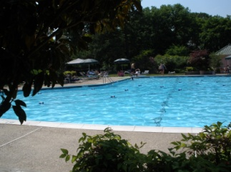

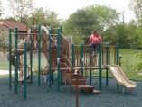
Swimming Pools. Next to the Smith House is one of two full-sized swimming pools. The second is located in Parcel I. Both pools have small pool areas for young children. The pools are open to all residents with recreation badges from about Memorial Day through Labor Day. Residents are required to sign in with the lifeguards who enforce the pool rules which are derived from state law, safety and insurance considerations and are posted at the pool entrances. Days and hours the pools are open are announced at the beginning of each season.

Tot Lot. A children’s playground with a jungle gym is located next to the pool in Parcel I.

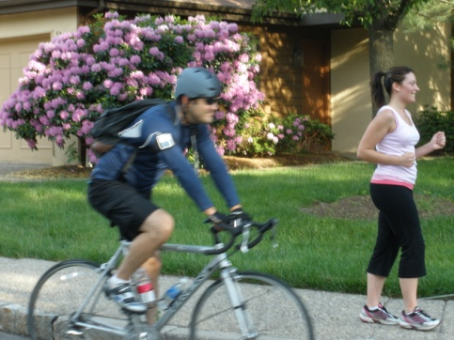
Sidewalks and Trails. There is a one-mile long oval loop road around which the twelve parcels are located. Walkers and cyclists take advantage of the road, sidewalks and walkways that transverse the parcels. Several areas in Princeton Landing are preserved as open meadows. Princeton Landing is also adjacent to Carnegie Lake with the tow path that runs the length of the Delaware-Raritan Canal and is frequented by cyclists and walkers.

Dog Stations. There are several stations along the loop road and paths in which to deposit the refuse. Dog owners are required to pick up after their pets.

Tennis, Basketball and Handball Courts. There are four tennis courts painted to match those at the US Open. These courts are open all year although most nets are taken down in late fall. Located next to the tennis courts is a one half basketball court with a wall that also serves as a tennis practice and handball court.

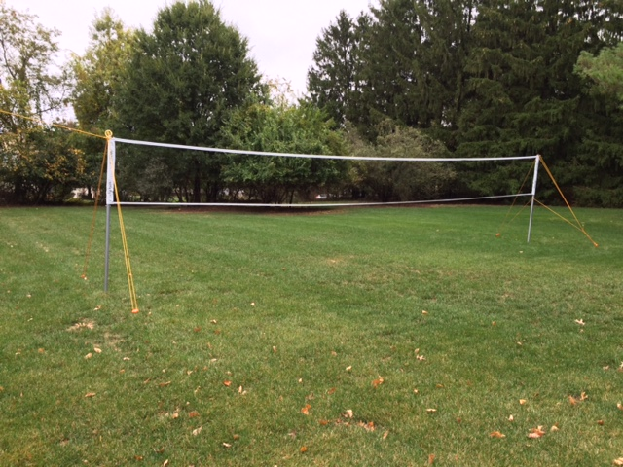
Volleyball – There is now an Olympic size net set up on the grass by the tennis court parking lot for use by adults and children at any time. Volleyballs and badminton racquets are available in the plastic storage bin inside the tennis courts-Mgmt can give you a key.

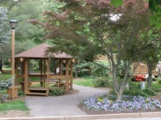
Gazebo. The gazebo in Parcel II on the loop road serves as a school bus stop, a resting place for walkers and a meeting place for residents.

